**Test Analysis**

|  |  |  |  |  |
| --- | --- | --- | --- | --- |
| Test Case ID | Test Scenario | Expected result | Actual result | Status |
| 1 | Verify if searching the product “Nike react phantom run flyknit 2” shows right product. | It will show the searched product only. | It is showing the right product. | Pass |
| 2 | Verify if black color small size shoes can be added to cart. | Black colour small size should be added to cart. | Green colour small size is added to cart. Pink colour was added to cart when I tested before. Proof given below. | Fail |
| 3 | Verify if “We do not have enough stock” showing if stock is limited. | It will show “We do not have enough stock” if I add more than one pair of this Pair. | Sometime it shows “We do not have enough stock” and sometime it doesn’t shows any message if I add more than one pair. | Fail |

* Different time different colour is been added to cart, where I selected Black small size every time.

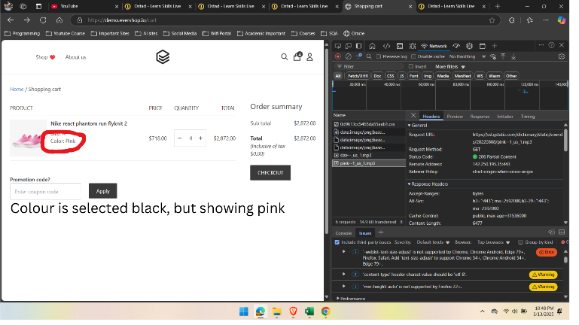

Tested at 13/03/25 Tested at 15/03/25

* Different time it shows “We do not have enough stock” if I add more than one pair of this same model.

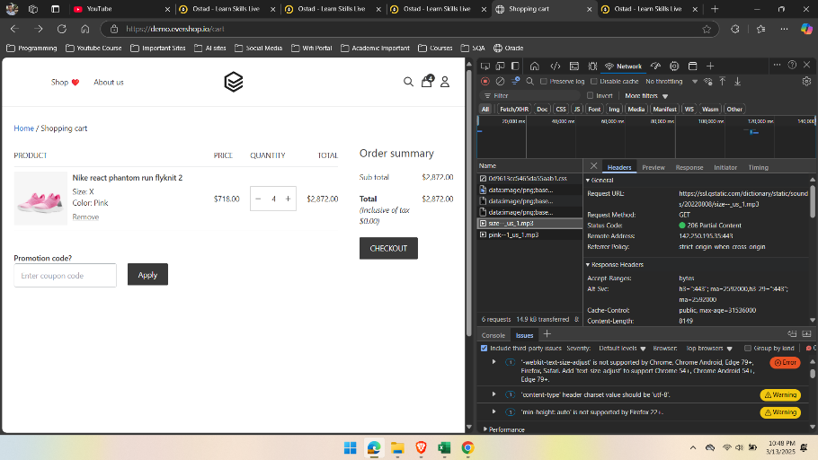

No message of “We do not have enough stock” after adding 4 quantities to cart. Testing Date: 13/03/25

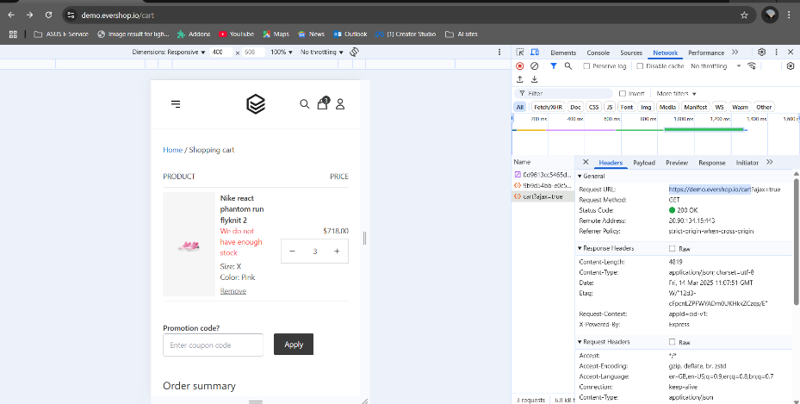

Error message showing “We do not have enough stock” after adding 3 quantities to cart. Testing date: 14/03/25